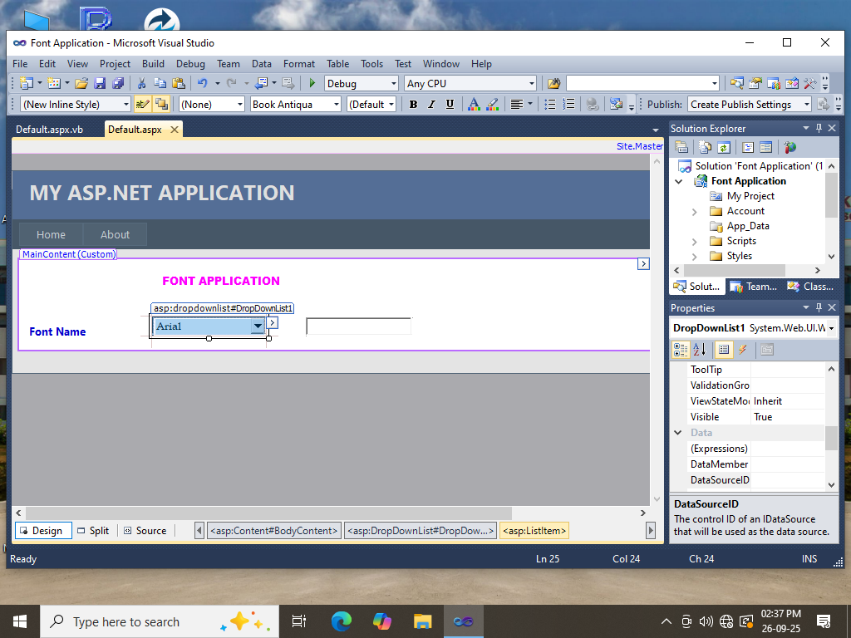

Public Class _Default

Inherits System.Web.UI.Page

Dim selectedfont As String

Protected Sub DropDownList1_SelectedIndexChanged(ByVal sender As Object, ByVal e As EventArgs) Handles DropDownList1.SelectedIndexChanged

selectedfont = DropDownList1.SelectedValue

Label2.Font.Name = selectedfont

TextBox1.Font.Name = selectedfont

End Sub

End Class

